

Pallet Shipment Program
Architecture

Revision History
Date | Version | Description | Author
08/20/2013 | 1.0 | Created | Jim Heary
09/12/2013 | 2.0 | Updated for Iteration 2 | Jim Heary
01/21/2014 | 3.0 | Updated for Iteration 3 | Jim Heary
02/06/2014 | 4.0 | Updated for Iteration 4 | Jim Heary
03/06/2014 | 4.1 | Revised | Jim Heary
10/15/2014 | 5.0 | Revised for Iteration 5 | Jim Heary

Table of Contents
Introduction 4
Overview 4
Scope 5
Risks 5
Business Activities 6
Quick Rate Quote (Request Quote) 6
Enroll 7
Book Quote 8
Pickup Shipment 9
System Analysis 10
Overview 10
Actors 10
Use Cases 11
Request Quote 11
Enroll Client 11
Approve Client 12
Create Shipper 12
Create Consignee 12
Book Quote 12
Update Shipment 13
Cancel Shipment 13
Notify 13
Dispatch Shipment 13
Print Labels 14
Print Manifest 14
Business Rules 14
Non-functional Requirements 14
Presentation 15
Performance 15
Security 15
Availability 15
Concurrency 15
Interoperability 15
Key Abstractions 16
States 17
System Design 18
Overview 18
Design Model 18
Structure 18
Behavior 21
User Interfaces 21
Persistence 22
Availability 22
Concurrency 22
Security 22
Deployment 24
Project Planning 25
Iteration 1 25
Iteration 2 25
Iteration 3 25
Iteration 4 25
Iteration 5 25
Appendix 26
Reports 26

Introduction
Overview
Argix Logistics would like to expose its business capability for moving LTL pallet shipments to a wider audience. This capability would allow anonymous users and approved clients to obtain quotes for LTL pallet shipments from an Internet web site. In addition, approved clients would book and manage their own quotes. Argix Logistics would like to backhaul these LTL pallets to the local terminals; delivery would be nationwide.

This document details known requirements and a candidate design. It does not address manpower requirements or project scheduling, although these can be determined from this architecture. Also, it does not cover Tsort integration as this is being addressed outside of this architecture.

How to read this document
Management- Introduction, Analysis (Overview, Business Activities, Actors), Project Planning
Operations- Introduction, Analysis, Project Planning
IT- Introduction, Analysis, Design, Project Planning

Context
The following diagram provides context for the system under discussion. This is a high level view of the structure of the system. At the center of the drawing is the system under discussion (i.e. Pallet Shipment). Surrounding this system are roles, devices, and other systems that interact with the system. it helps us to understand the people, hardware, and external systems that interact with the system under discussion.

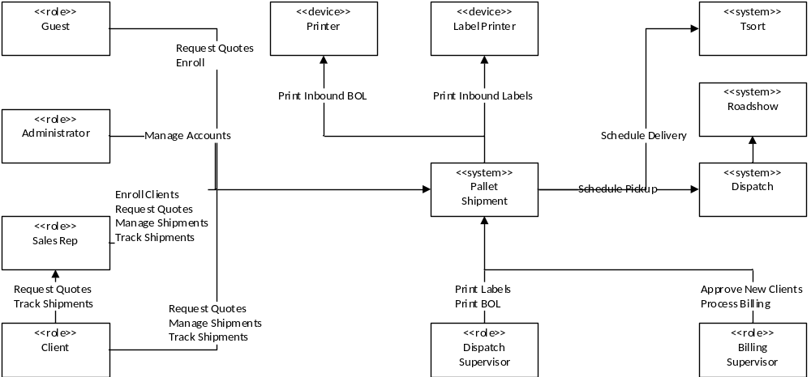

Scope
Solution Boundary
The solution will provide client interaction over the Internet for creating online quotes, managing booked quotes, and shipment tracking. It will provide pallet rates for online quotes per Finance managed rate structures and Operations managed pickup and delivery locations. It will provide automatic billing of processed shipments from the original quotes (subject to revision by the actual shipment). Dispatch will be used to manage pickups from shippers; also, Roadshow will be used for pickups and deliveries made by Argix local terminals. Tsort will be used to manage deliveries to consignees and for delivery tracking.

Constraints
- Freight pickups are available from the Argix Ridgefield local terminal only, with later adoption in all Argix local terminals.
- Freight deliveries are available to all locations serviced by the Argix delivery network (nationwide) as supported by the Argix local terminals and Argix agent terminals.
- The Dispatch System will be used to manage freight pickups. Integration should be completely automated.
- The Tsort system will be used to manage freight deliveries. Integration should be completely automated.
- The solution should conform to the principles of a Service Oriented Architectures (SOA).
- The solution will use the current Microsoft-based platform and Microsoft-based development tools.

Risks
- The business process is under construction and not well understood at this point. This risk can be mitigated with rigorous analysis, prototyping, and an iterative development effort.
- Using BizTalk Server for application integration is a new approach and there are risks due to inexperience in designing, building, and maintaining a solution. These risks can be mitigated by developing a parallel manual solution (i.e. user driven).
- Tsort integration has no published design or development schedule; this impacts project planning, scheduling, and potentially the design and implementation of other parts of the system. This risk can be mitigated by design scoping and development planning and scheduling.

Business Activities
The following diagrams show the business activities for the Pallet Shipment Program. Business activities are modeled using activity diagrams. Activity diagrams show a series of activities, the actors responsible for each activity, and the information consumed and created during the process. These diagrams use the language of the business. Activity diagrams drive the discovery of Actors, Use Cases, and Key Abstractions.

Quick Rate Quote (Request Quote)
A Guest or a Client requests a quote for a pallet shipment. The user enters shipment information and requests a quote. The system logs the quote (for reporting and analysis) and returns the quote to the user.

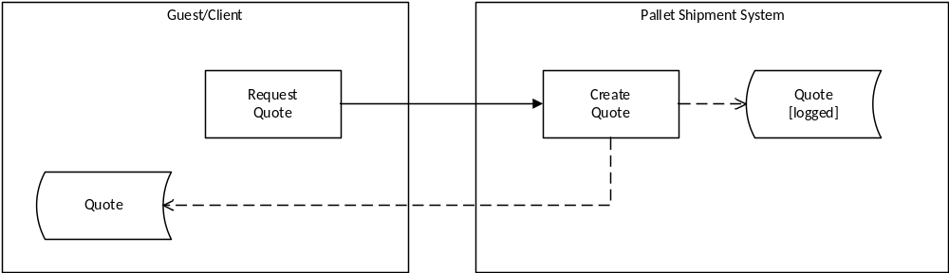

Enroll
A Guest chooses to Enroll as a Client in the system; the Guest could be a Client or a Sales Rep. The user enters applicable enrollment information. The system creates a Client login account, creates a Client, sends a welcome notification to the user, and sends a new client notification to Finance. Finance must approve a new client (i.e. perform a credit check). If the client is approved, the system changes the client state from new to approved and sends a client status notification to the user. The user is now a Client and can book shipment quotes.

If the Client is a Sales Rep, he will have to contact Argix Logistics to be granted the role of a Sales Rep.

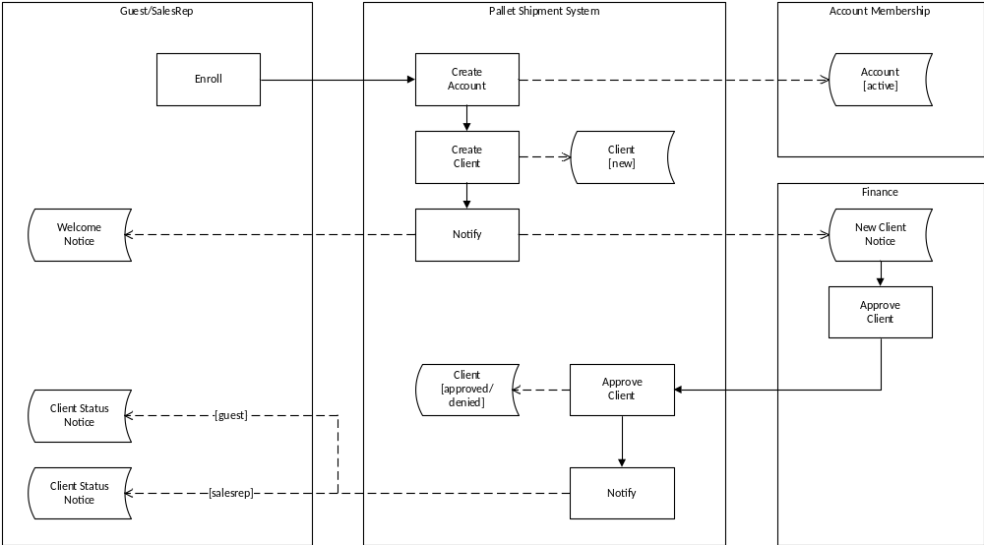

Book Quote
An approved Client requests a quote for a pallet shipment and chooses to book the quote. The user logs into the system and chooses to create a quote. The user selects an existing shipper or creates a new one. The user selects an existing consignee or creates a new one. The user enters additional shipment information and requests a quote. The system logs the quote (for reporting and analysis) and returns the quote to the user. The user chooses to book the quote. The system creates a shipment (requested) based upon the quote, sends the user a confirmation notification, and schedules a pickup request for the shipment in the Dispatch System.

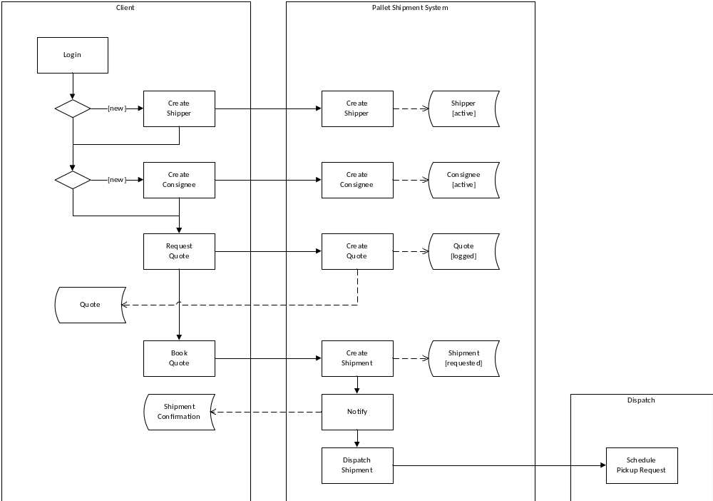

Pickup Shipment
A new shipment is dispatched for pickup by the Dispatch System. After a client creates a new shipment, the Pallet Shipment System dispatches the shipment for pickup. Dispatch returns a pickup number and the Pallet Shipment system updates the shipment (dispatched). On the day of the pickup, the Pallet Shipment system prints the pallet labels and an inbound BOL (this can be automated, but also requires manual operation); Dispatch assigns a driver. The driver makes the pickup, affixes the labels to the pallets, and records any additional information on the BOL including accessorials which were not quoted. After the pickup is arrived by Dispatch, the Pallet Shipment system updates the shipment (arrived) with the arrival date.

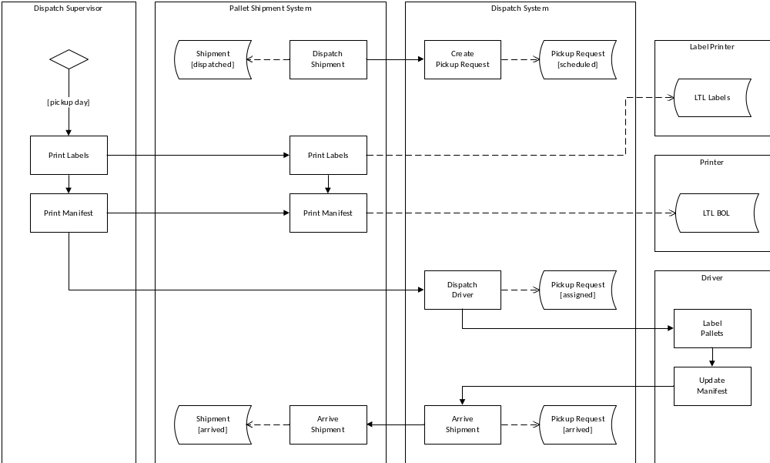

System Analysis

Overview
The purpose of defining system behavior is to discover, capture, and analyze the requirements of the system under discussion. This is achieved by describing the requirements (i.e. the conditions or capabilities to which the system must conform) well enough so that an agreement can be reached between the business users and the system developers on what the system should and should not do. It begins by modeling the business processes with a series of activity diagrams. These diagrams drive discovery of the users of the system (i.e. Actors), the system functionality (i.e. Use Cases), and the vocabulary of the system (i.e. Key Abstractions). From these artifacts, an analysis model is created that drives system design and development.

Actors
An actor specifies a role played by a user or any other system that interacts with the system under discussion. Actors influence UI design and security concerns. The list below provides definitions for the actors surrounding the Pallet Shipment system.
- Pallet Shipment- the system under discussion.
- Guest- an anonymous user who requests quick quotes and enrolls (register) as a Client.
- Client- requests quotes; books quotes; manages existing shipments; tracks shipments.
- Sales Rep- a Client who can additionally enroll new Clients that he can book quotes and track shipments on their behalf.
- Billing Supervisor- approves new clients; manages billing.
- Dispatch Supervisor-prints pallet labels and inbound paperwork (i.e. BOL).
- Administrator- manages login accounts including changing roles (i.e. Client to Sales Rep) and inactivating an account.
- Dispatch- Argix internal business system used to manage pickups from Argix National and local terminals.
- Roadshow- third-party system used for driver routing in the Argix local terminals.
- Tsort- mainframe-based system used for shipment delivery.

Use Cases
A Use Case is a list of steps, typically defining interactions between a role (i.e. Actor) and a system to achieve a goal. The actor can be a human or an external system. Use Cases describe the functional view of the system under discussion as a set of business transactions. Use Cases influence UI design, domain models, application service interfaces, and define business transactions. The following Use Case diagram shows some, if not all, of the actors and use cases involved in LTL Quote.

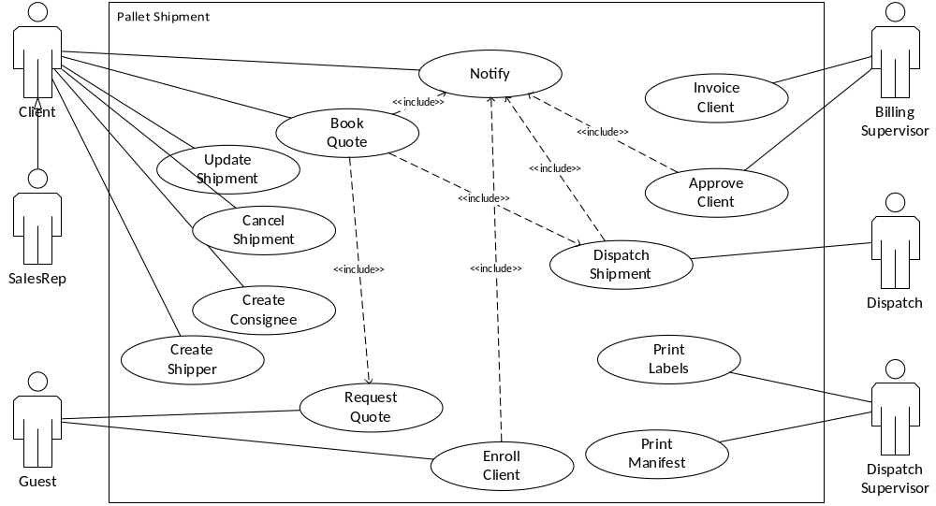

Request Quote
A Guest needs to request a quote for palletized freight. The user enters a shipping date, origin zip code, and destination zip code. The user enters up to 5 pallets specifying a class code and weight for each pallet. The user may also indicate accessorial charges including Inside Pickup/Delivery, Insurance, Pickup/Delivery Appointment, and Lift gate. The user submits the request.
The system creates a quote containing total pallets, total weight, pallet rate, FSC, accessorial charge, TSC, and total charge. The system records the quote and returns it to the user.
If the user is a Guest, the system allows the user to enroll as a client and book the quote.
If the user is a Client, the system allows the user to book the quote.
Enroll Client
A Guest needs to enroll in the system as a Client; additionally, a Sales Rep can enroll a customer on their behalf. The user enters account information including username, password, and email address. The user enters client information including name, address, city, state, zip, and contact name/phone/email. The user enters shipper information including name, address, city, state, zip, and contact name/phone/email. The user enters consignee information including name, address, city, state, zip, and contact name/phone/email. The user submits the enrollment information.
The system creates a login account (active).
The system creates a Client (new), and links the Client to the login account. If the user is a Sales Rep, the Client is linked to the Sales Rep.
The system notifies the user (i.e. email) of his account information. If the user is a Sales Rep, the Sales Rep is notified of the account information as well as the Client.
The system notifies Finance of the new user.
Approve Client
Finance needs to approve a new Client (i.e. credit check). They can approve or deny the Client. The system saves the date of the approval choice and the user making the decision. If approved, the system updates the Client state to approved. If denied, the system notifies the user of the denial and the Client state is updated to denied. If the Client has an associated Sales Rep, then the system notifies both the Sales Rep and the Client.
Create Shipper
A Client needs to create a new shipper. The user enters shipper information including name, address, city, state, zip, and contact name/phone/email.
The system validates that the shipper zip code is serviced by an Argix local terminal for pickups.
If he shipper is validated, then the system creates a new shipper (active).
Create Consignee
A Client needs to create a new consignee. The user enters consignee information including name, address, city, state, zip, and contact name/phone/email.
The system validates that the consignee zip code is serviced by an Argix agent terminal for deliveries.
If the consignee is validated, then the system creates a new consignee (active).
Book Quote
A Client or a Sales Rep needs to book a new quote.
Pre-Conditions:
The Client is logged into the system and is approved by Finance.
Flow of Events:
Basic Path
- If the user is a Sales Rep, he can select one of his Clients.
- The user enters a shipping date.
- The user selects a shipper; he can choose to create a new shipper (see Create Shipper).
- The user selects a consignee; he can choose to create a new consignee (see Create Consignee).
- The user enters up to 5 pallets specifying weight for each pallet.
- The user may also indicate accessorial charges including Inside Pickup/Delivery, Pickup/Delivery Appointment, and Pickup/Delivery Lift gate.
- The user submits the request.
- The system returns a quote containing total pallets, total weight, pallet rate, FSC, accessorial charge, insurance charge, toll charge, and total charge.
- The user submits the quote.
- The system creates a new shipment (requested).
- The system returns a shipment number to the user.
- The system notifies the user (i.e. Email) to confirm the quote has been booked. If the user is a Sales Rep and has booked the quote on behalf of his Client, then the system notifies both the Sales Rep and the Client.

Alternative Paths
The system does not have a rate for the specified shipper and consignee pair.
- At step 7 in the Basic Path, the system returns an error message to the user specifying he will be notified (i.e. Email) once the quote is determined.
- The system notifies Finance that a rate is needed.
- TBD.

Post-Conditions: The shipment is saved.
Update Shipment
TBD
Cancel Shipment
TBD
Notify
The System needs to notify the user of an event (i.e. quote booked, client approved/denied). The system sends an email to the Client notifying them of the event and status.
Dispatch Shipment
A new shipment needs to be scheduled for pickup with the Dispatch System. This is a long running business transaction.
Pre-Conditions:
A new shipment was created.
Flow of Events:
Basic Path (Automated)
- The system schedules a pickup request (scheduled) in the Dispatch Pickup Log Advanced Schedule.
- The system updates the shipment (dispatched) with the pickup ID.
- On the day of the pickup, the system prints the pallet labels to a label printer in Dispatch and prints an inbound manifest to a printer in Dispatch.
- The system updates the shipment (departed) with the BOL number.
- When the pickup is arrived by Dispatch, the system updates the shipment (arrived) with the current date and time of arrival.

Alternative Path (Manual)
- The user views a list of shipments (new) that have not been scheduled for pickup.
- The user selects a shipment and chooses to schedule the shipment in the Dispatch Pickup Log.
- The system schedules a pickup request (scheduled) in the Dispatch Pickup Log Advanced Schedule.
- The system updates the shipment (dispatched) with the pickup ID.
- On the day of the pickup, the user views a list of shipments (dispatched) which are scheduled for pickup.
- The user selects a shipment and chooses to print the pallet labels and an inbound BOL.
- The system prints the pallet labels to a label printer in Dispatch.
- The system prints an inbound BOL to a printer in Dispatch.
- The system updates the shipment (departed) with the BOL number.
- When the pickup is arrived, the user views a list of shipments (departed) that have departed for pickup.
- The user chooses the shipment that matches the shipment number, pickup ID, or inbound BOL number.
- The user chooses to arrive the shipment.
- The system updates the shipment (arrived) with the current date and time.

Post-Conditions: The shipment is arrived.
Print Labels
Operations needs to print a label for each pallet in a shipment. The system prints the labels to a label printer in Dispatch on the morning of the scheduled pickup. Five labels are printed in case the shipment includes more pallets than originally specified. The label contains the shipment number, the pallet number (barcode and human-readable), the name and number of the client, the name and address of the shipper, the name and address of the consignee, and the insured value (if applicable).
Print Manifest
Operations needs to print an inbound BOL for a shipment prior to pick up from the shipper. The system prints the BOL to a printer in Dispatch on the morning of the scheduled pickup. The BOL contains standard BOL information; additionally, it shall include pickup accessorials for inside pickup, lift gate, and appointment to be verified by the driver making the pickup.

Business Rules
- Booking additional shipment requests is subject to a credit limit on the account.
- New shippers must be valid Argix local terminal pickup locations.
- New consignees must be valid Argix agent delivery locations.
- Rate quote pricing is as follows:
Pallet rate = tiered pricing will be used, one tier set per LTL zone.
FSC = depends on National fuel region, fuel region of pickup terminal, and National weekly fuel cost; will be applied to the pallet charge only.
Accessorials= will have a rate per LTL zone for each accessorial type (i.e. inside pickup, lift gate, etc.).
Insurance = pallet value up to $600 no charge; pallet value greater than $600 apply a rate of $4.75 per additional $100 of coverage with an $85.50 minimum. Maximum liability(coverage) $10,000 per pallet.
TSC = based on the 3 digit consignee zip regardless of shipper/pickup terminal.
Total charges = number of pallets x pallet rate + FSC + Acccesorials+ Insurance + TSC
- Customer discounts are applied as follows: each client can have an individual discount; discounts will be the same for every tier and LTL Zone; each client can have a single discount per accessorial charge which will be applied to any LTL zone.
- Shipment booking restrictions

Non-functional Requirements
Presentation
Thin client user interface accessible from desktop for customers. Rich client user interface for Argix employees. No tablet or mobile at this point.
Performance
Unspecified.
Security
Authentication
Customers- users will require Forms authentication after creating a role-based login account.
Argix Employees- employees will be authenticated by the Argix network domain.
Authorization
Customers- role-based authorization (i.e. guest, client, sales rep) using Forms accounts.
Argix Employees- role-based authorization (i.e. administrator, finance, operations) using domain accounts.
Availability
24-7.
Concurrency
Customers- support 5-50 simultaneous users;
Employees- support 2-5 simultaneous users.
Interoperability
Dispatch- required to manage shipment pickup. Dispatch requires an existing Tsort client; Pallet Shipment shippers do not need corresponding Tsort Vendor to dispatch the pickup from Argix National; but if a Tsort Vendor does not exist, then the local terminal will have to dispatch manually. Dispatch services are available through a WCF web service.
Roadshow- required to route shipment pickup and delivery in the local terminals. Pallet Shipment shipper and consignee locations must be existing Roadshow delivery points to be part of a Roadshow route solution; otherwise, routing is done manually. Roadshow services are exposed as SQL stored procedures.
Tsort- required to manage shipment delivery. Tsort requires a Tsort client; the Pallet Shipment consignee must exist as a store for the Tsort client. Tsort services are exposed as SQL stored procedures.

Key Abstractions
The class diagram below shows the key abstractions involved in Pallet Shipment. Key abstractions are the key concepts and abstractions that the system needs to handle. They are those things that, without which, you could not describe the system. Key abstractions drive design of the database schema and the domain model (if applicable).

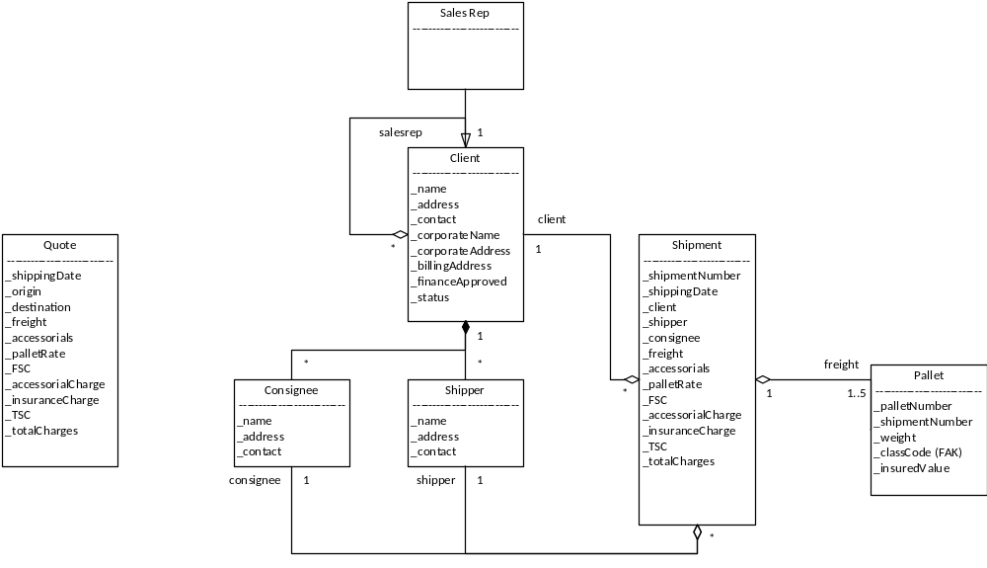

- Quote- a quote captures a shipment request and an associated rate from a guest or client.
- Client- a Customer who has created a membership (login) account with an associated Client account; a Client may have an associated Sales Rep.
- Sales Rep- a Client who can serve as a proxy for other Clients.
- Shipper- a qualified origin for a pallet shipment; Shippers are owned by a Client.
- Consignee- a qualified destination for a pallet shipment; Consignees are owned by a Client.
- Shipment- a booked quote for a pallet shipment. Quotes reference a single Client, a single Shipper, a single Consignee, and 1-5 Pallets.
- Pallet- the freight specified by the Quote. A single Quote can specify 1-5 pallets.

States
The state machine view describes the dynamic behavior of objects over time by modeling the lifecycles of objects of each class. Each object is treated as an isolated entity that communicates with the rest of the world by detecting events and responding to them. Events represent the kinds of changes that an object can detect. Anything that can affect an object can be characterized as an event.

Shipment
A shipment is in a new state once created by event Book Quote.

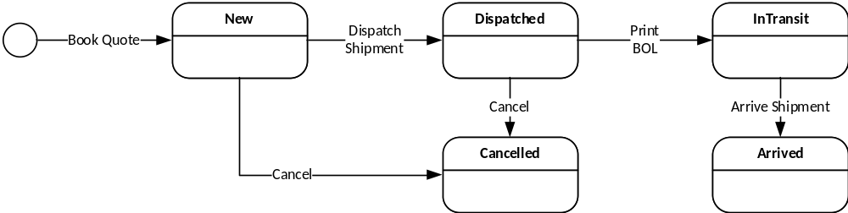

Client
A client is in a new state after event Enroll. Finance approves the client (i.e. credit check), and the resulting state is approved or denied. If approved, quotes re available for operations to approve. An approved client can be made inactive to halt further quote activity.

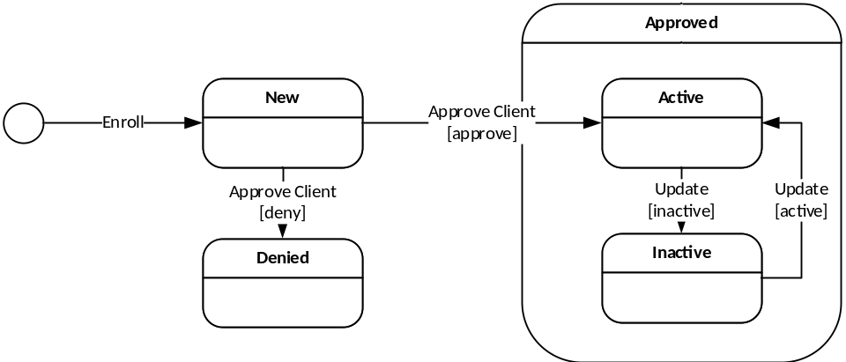

System Design

Overview
The system design includes a thin web client for Internet access by anonymous users for obtaining quick rate quotes and optionally to enroll as a client of Argix Logistics. Also, it enables approved clients to obtain quick rate quotes, book the quotes, and manage their shippers, consignees, and shipments. The design also includes a rich Windows client that provides management of Clients (i.e. approval) and reporting. Both user interfaces access back-end databases through web services arranged in a Service Oriented Architecture (SOA). Integration with Dispatch is accomplished with Microsoft BizTalk Server, an enterprise service bus that provides application integration and orchestrated workflows across disparate systems in an SOA environment. Security is provided by two ASP.Net membership databases, one hosting domain accounts and the other hosting login membership accounts. Program services are secured using pre-defined user roles.

Design Model
Structure
The design is a n-tier physical and logical design composed of a .NET 4.0 Win Forms client (PalletShipment.exe) and an ASP.NET 4.0 Web Forms client (http://<server>PalletShipment), several .NET 4.0 WCF Services (Argix10.Freight.Services), and a SQL Server 2008 R2 database. The design as a whole is built to conform to a Service Oriented Architecture. Service Oriented Architectures describe ways to build loosely-coupled systems composed from individual services. Application integration (i.e. scheduling pickups in Dispatch) is accomplished in an SOA environment using Microsoft BizTalk Server 2010. All software components are built with Microsoft Visual Studio 2010 and compiled to operate in.Net 4.0 framework environments. The structures of the design are defined by drawings of the components and interfaces. The behaviors of the design are defined by sequence diagrams involving the interactions between the components.

Enterprise Patterns
In software engineering, a design pattern is a general reusable solution to a commonly occurring problem within a given context in software design. It is a description or template for how to solve a problem that can be used in many different situations. Patterns are formalized best practices that the programmer must implement in the application. Object-oriented design patterns typically show relationships and interactions between classes or objects, without specifying the final application classes or objects that are involved. The following enterprise design patterns are used in throughout the design:

Transaction Script- a Transaction Script organizes business logic by procedures where each procedure handles a single request from the presentation. They are an excellent choice when we don’t have a middle tier domain model. Transaction scripts are used in the web services to provide business transactions and security for one or more use cases.
Gateway- a Gateway is an object that encapsulates access to an external resource such as a web service or database server. Gateways are used throughout the design for user interface access to middle tier web services, for web service access to backend database services, and for web service access to external hardware including a label printer.
Record Set- a Record Set is an in-memory representation of tabular data; record sets (i.e. DataSet) work well with .NET user interface components.
Data Transfer Object- a Data Transfer Object (DTO) is an object that carries data between processes in order to reduce the number of method calls. Data Transfer Objects are serialized classes exposed by the interfaces of the web services for transactional calls to the middle tier (i.e. LTLService::CreateShipper(Shipper shipper)).

Pallet Shipment Structure
The following drawing shows the components and interfaces (structure) of the Pallet Shipment design, and the connections between the various components. Components are denoted with tabbed containers. The rectangles within the components are software units stereotyped with their functional purpose such as a gateway or transaction script. There are two user interface components, a WinForms client (PalletShipment.exe) and a web client (http://<server>PalletShipment). Each user interface component uses the recordset for data caching; each accesses the middle tier web service using a gateway. The Freight web service (Argix10.Freight.Services) exposes two interfaces from a single transaction script: LTLService: ILTLClientService provides methods that support the use cases for clients to obtain quotes and manage shipments; ILTLAdminService provides methods for Argix employees to view and approve clients. The LTLService communicates with a Tsort database through a gateway; with a web service front end (BizTalk.Freight.Services) to a BizTalk server through a gateway, and to a web service front end (Argix10.Enterprise.Services) to an SMTP server through a gateway.

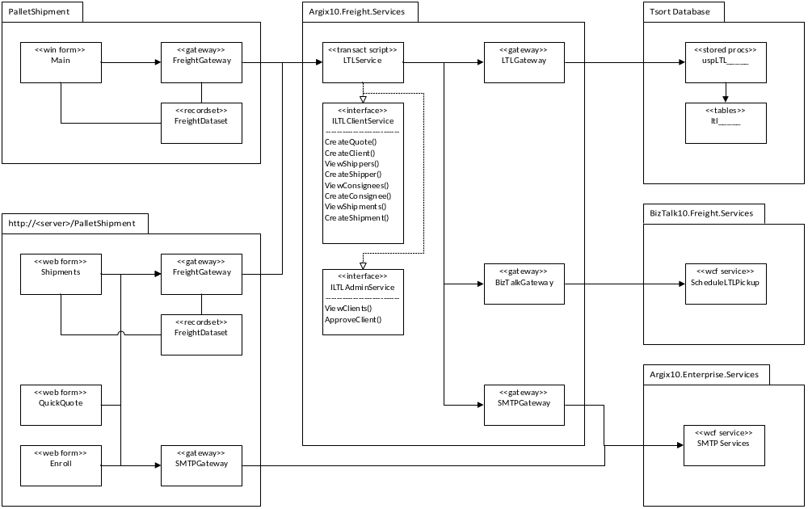

Dispatch Integration Structure
The following drawing shows the components and interfaces of the Pallet Shipment design concerned with Dispatch integration using BizTalk services. A workflow orchestration is designed using Visual Studio 2010 and deployed to a BizTalk Server 2010. The orchestration is exposed to the SOA environment as a Wcf service (BizTalk.Freight.Services). This service uses an MSMQ transport so as not to block the client (Argix10.Freight.Services) when creating and dispatching a shipment. Argix10.Freight.Services includes separate services for Pallet Shipment (LTLService) and for Dispatch (DispatchService). Additionally, a new service (FreightSystemService) was created for BizTalk Server to communicate with the Pallet Shipment System through interface ILTLSystemService, and the Dispatch System through interface IDispatchSystemService. The behavior of this structure is defined in the next section: Behaviors.

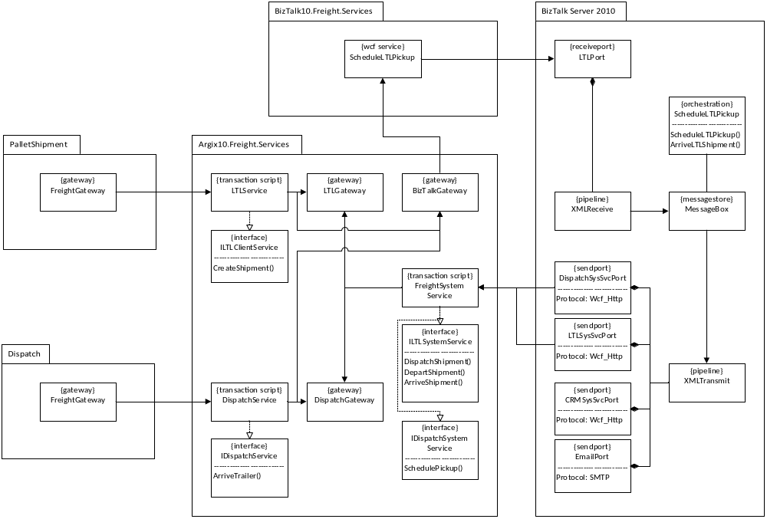

Behavior
Dispatch Integration Behavior
The following drawing shows the behavior of the Dispatch Integration structures in dispatching and arriving an LTL shipment. In the middle of this is BizTalk Server, which hosts an orchestration for coordinating the long running business transaction. The FreightSystemService allows BizTalk to interact with the Pallet Shipment System and with the Dispatch System.

The orchestration is developed using Visual Studio 2010 and is deployed to a BizTalk 2010 server. In addition, the orchestration is exposed to an SOA environment by using the BizTalk WCF Services Publishing Wizard to publish a WCF service to a LAN-based IIS 7.5 web server.

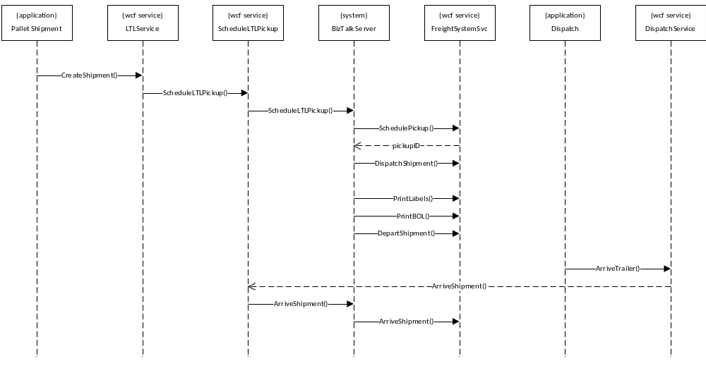
User Interfaces
Web Client
The Pallet Shipment web application is built using ASP.NET Web Forms for the .NET 4.0 Framework. It uses HTML5 and CSS3 in the browser; additionally, JQuery is used for client-side behaviors like pop-up calendars, input masks, and data validation. The web application communicates with a middle-tier Wcf service using the WcfHttpBinding binding. It is secured using an ASP.NET Membership services database.

The application is built using Visual Studio 2010 and is deployed onto an Internet-facing IIS 7.5 web server.

Windows Client
The Pallet Shipment Windows application is built using .NET WinForms for the .NET 4.0 Framework. It communicates with a middle-tier Wcf service using the WcfHttpBinding binding. It is secured using an ASP.NET Membership services database through a Wcf Role Service.

The application is built using Visual Studio 2010 and is deployed onto a LAN-based IIS 7.5 web server where it is deployed to client computers using the Click-Once technology.

Persistence
Database Schema
The database schema is largely derived from the Key Abstractions. The following drawing shows the core schema required; what is not shown are tables concerning pallet rating and valid pickup/delivery locations.

The database is built and deployed with a SQL Server 2008 R2 database server. The schema is exposed through stored procedures.

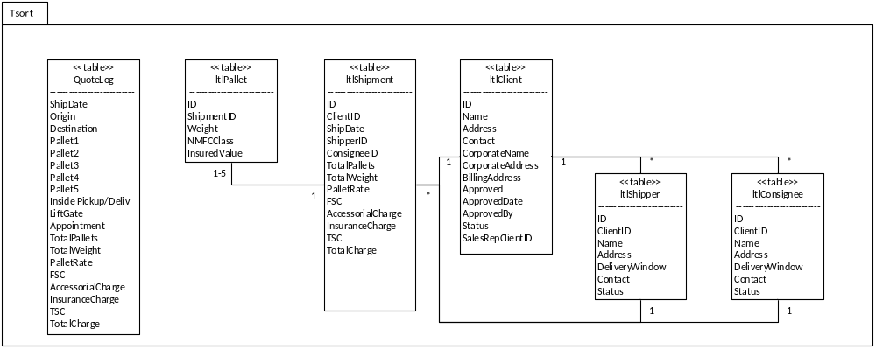

Availability
As dictated by the platform.

Concurrency
There are no entities that require concurrent access.

Security
Authentication
Web application: Forms-based login and ASP.NET Membership Services.
Windows application: Windows network login.

Authorization
The windows application uses ASP.NET role-based security to authorize access to application features and services. The RoleServiceGateway encapsulates the details to access the RoleService from the MembershipServices web service. The RoleServiceGateway also acts as a policy file where role-based access is queried by user interface objects. The following drawing shows the processes and components that realize the application authorization design.

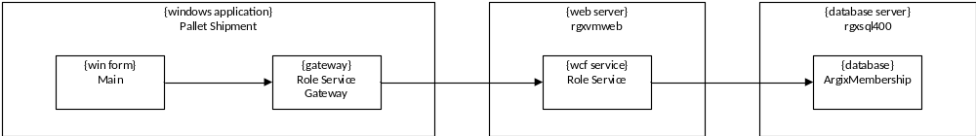

The web application uses ASP.NET role-based security to authorize access to application features and services. Each web form has access to global objects accessible from the System.Web.Security .NET component. These global objects are made accessible to the application by adding security entries to the ASP.Net configuration file (i.e. web.config) including <authentication>, <membership>, <profile>, and <roleManager> sections of <system.web>. An example configuration file is shown in the Appendix. The following drawing shows the processes and components that realize the application authorization design.

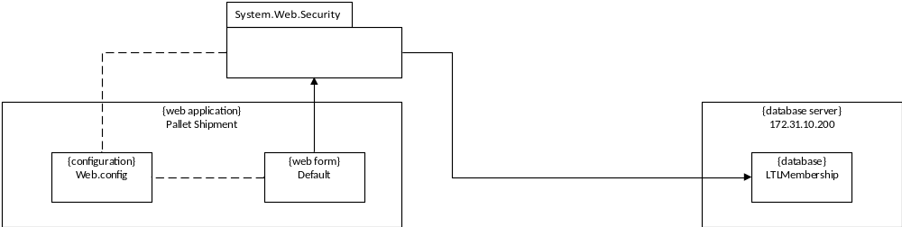

Deployment
The current deployment consists of a centralized application on the Jamesburg local area network (LAN) with client computers running on the Jamesburg LAN as well. Access to the application will be via the Argix Corporate Portal (i.e. SharePoint) using a Click-Once deployment that assumes the deployment server is always available; although the deployment is cached on the client, the server is always checked for a version update. Additional information concerning the click-once deployment can be found in the release notes accessible from the Help menu.

The deployment platform is as follows:
- Client- Windows7 operating system with .NET Framework 4.0 (full, not client)
- Web/Application Servers- Windows Server 2008 R2 and IIS 7.5 with .NET Framework 4.0
- Database Servers- Windows Server 2008 R2 and SQL Server 2008 R2
- Enterprise Service Bus- Windows Server 2008 R2 and BizTalk Server 2010
- Reporting Server- Windows Server 2008 R2 and SQL Server Reporting Services 2008 R2

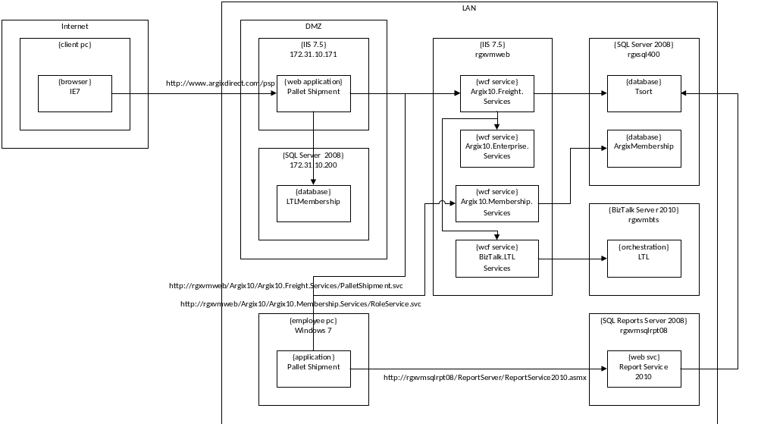

Project Planning

Iteration 1
Implement the following Use Cases:
Request Quote
Enroll Client

Iteration 2
Implement the following Use Cases:
Approve Client
Create Shipper
Create Consignee
Book Quote
Notify

Iteration 3
Create an interim production release that includes the following Use Cases:
Request Quote
Enroll Client
Approve Client
Request Pickup- this use case is not documented

Iteration 4
Implement changes required for a Sales Rep and the following Use Cases:
Dispatch Shipment
Print Pallet Labels
Print Inbound BOL

Iteration 5
Implement the following Use Cases:

Appendix

Reports
Quick Rate Quote Log

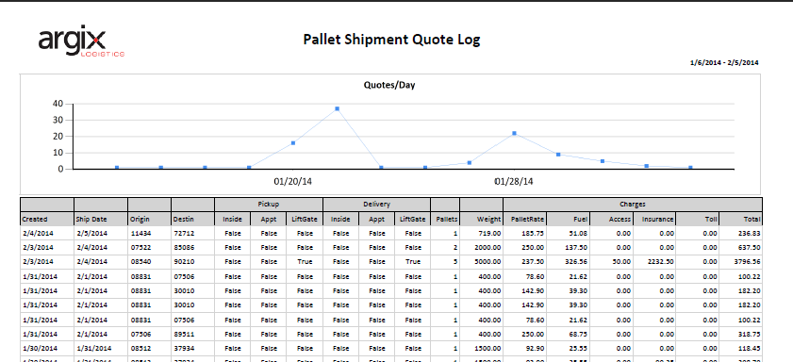

Dispatch Pickup Log

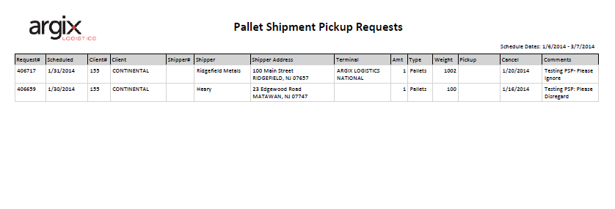

Dispatch Integration Workflow
The following drawing shows a BizTalk workflow that provides integration with the Dispatch System.

